Internship Report
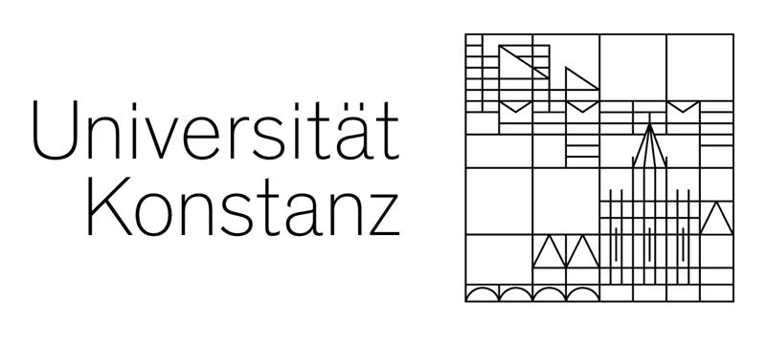
  - Fabian Sklar – 04/16/2024

My name is Fabian Sklar, I am currently studying Life Science M.Sc. at the University of Constance in Germany. From January 2024 to March 2024 I completed an internship at HHL group.
On my first day, I met Prof. Liao who gave me a short introduction into the research topics and introduced me to the members of his research group. I also got to know Zheng-Lin Zhan, a PhD student of HHL group, and my supervisor for the duration of the internship. He gave me an introduction into his work, showed me the laboratory including my working area for the next months, and explained to me how to use the research group’s chemical data bank. On the following days, Zheng-Lin Zhan showed me all the materials and methods, which were necessary to prepare and execute my syntheses. Furthermore, he introduced me to the purification and analysis methods, which are commonly used by the research group.
At Liao group, Zheng-Lin Zhan is working on 1-azabicyclo[1.1.0]butane (ABB), which belongs to the substance class of azetidines. Azetidine derivates seem to be important and beneficial substances in medical chemistry. Members of H.H. Liao’s research group discovered a new strategy to synthesize different substituted azetidines in an easier and faster way than by conventional synthesis.
My main task during the internship was the synthesis of different starting materials for Zheng-Lin Zhan’s ABB syntheses.
The further the internship progressed, the more independent I was working in the lab. At the end of the internship, I did the necessary research to find suitable synthesis routes, planed the execution of the syntheses and synthesized the desired products independently. I also purified the synthesized products and checked their purity, using gas chromatography and NMR analysis. If there were any problems or open questions, I always had the opportunity to ask Zheng-Lin Zhan or other HHL group members for their help. They were always very kind and willing to help me.
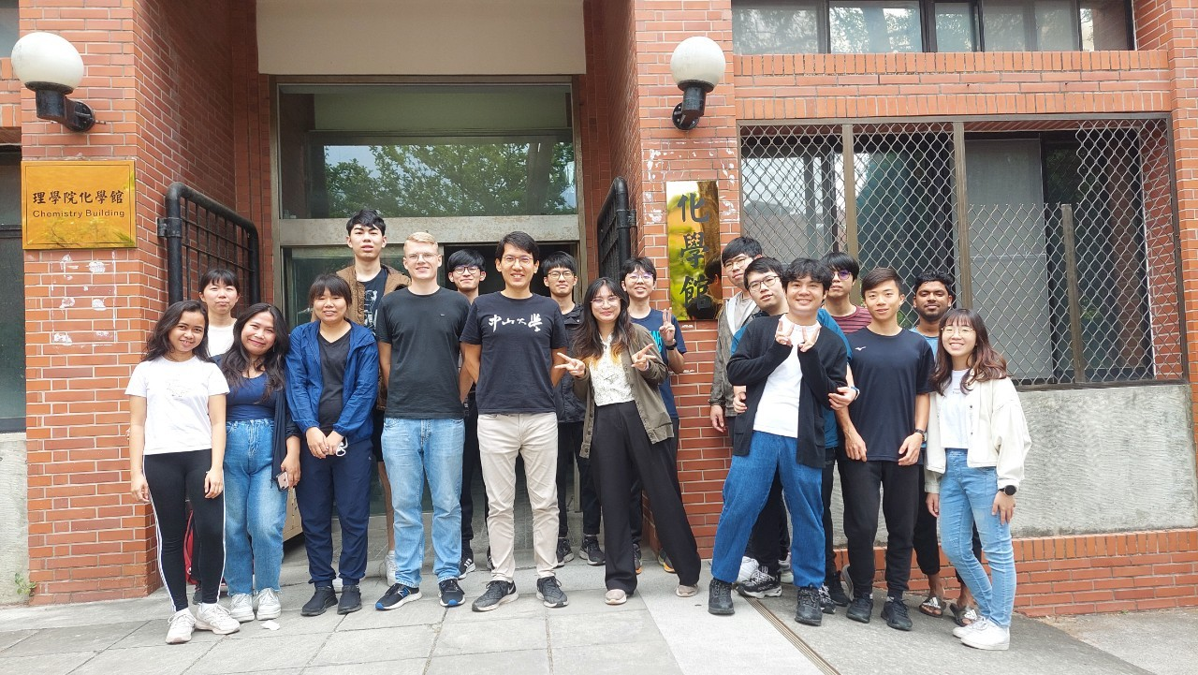
I really enjoyed the work environment at the HHL group. During my conversations with the group members, I was able to gain a lot of knowledge about organic chemistry, but also about the culture of Taiwan and other Asian countries. Every Thursday evening, the HHL group is going for a run or a walk near the univer-
sity, followed by having dinner together in a typical Taiwanese restaurant. This is where I got to know the group members personally and got in touch with the traditional and local cuisine. During the weekends, I was able to travel to many different regions and cities in Taiwan. Some of the highlights were Taroko National Park, Sun-Moon Lake, Jiufen, Kenting National Park, Taipei and Xiaoliuqiu. The public transportation in Taiwan is very convenient, which made it easy for me to travel across the country. During these weekend trips, I realized how beautiful Taiwan is. There are amazing mountain areas as well as tropical forests and beautiful beaches.
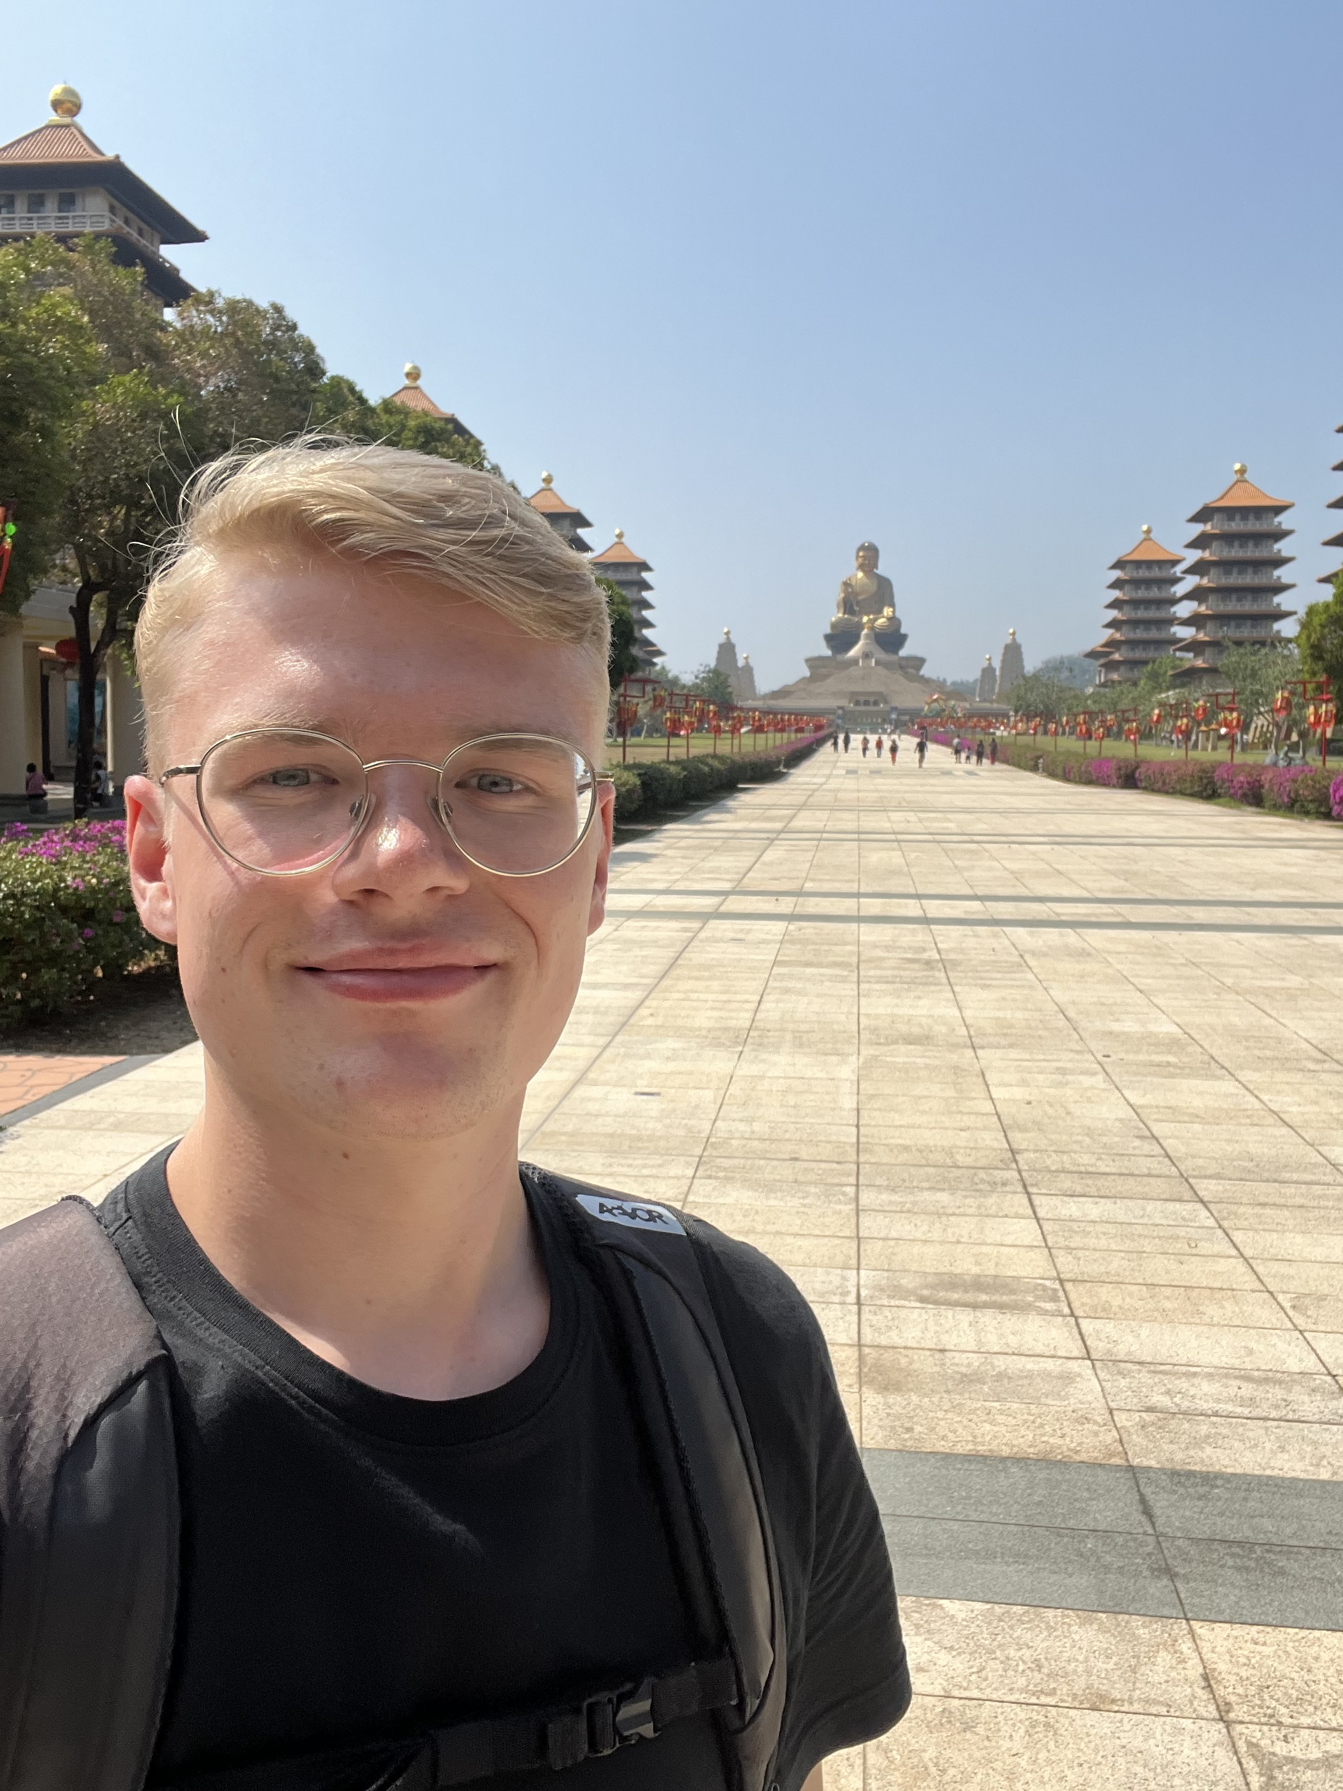

On my weekend trips, I met a lot of people which were very kind and open hearted. Most of them told me stories about the history and the culture of Taiwan or introduced me to the regional food. Therefore, the trips to the most beautiful places in Taiwan also gave me a deep insight into the history and culture of Taiwan.
Generally, the Taiwanese people were extremely friendly. As I don’t speak mandarin, I had some problems to read signs or the menu at Taiwanese restaurants. They were always people willing to help me. Even if these people couldn’t speak English, they were trying to communicate with me using hand signs or their smartphones to translate.
Summarizing, I really enjoyed the time at HHL group. I was able to gain a lot of theoretical and practical knowledge in organic chemistry and had a lot of fun in the lab. Furthermore, I had open hearted group members, which always tried their best to teach me new things about chemistry, but also about their culture, their religion and their daily life in Taiwan. I am very thankful for my time at HHL group and all the nice people that I met during this great time.
